Re-Simulation of the MDT-ASD chip

Version 1.1 – 29 April 2008

Sergey Abovyan, Yerevan Physics Institute, abovyan@mppmu.mpg.de

Varuzhan Danielyan, Yerevan Physics Institute, danielya@mppmu.mpg.de, var.danielyan@gmail.com (for large attachments)

Introduction

The aim of the work is the design of an upgraded version of the MDT-ASD chip which would be able to operate under the high hit rate, expected at the SLHC at CERN. The SLHC is the name of upgrade program of the LHC forwards higher luminosities.

To optimize the efficiency for recorded hits from the MDT at SLHC rates of up to 1.5 MHz per tube, the dead time of the signal chain in the frontend chip must be as small as possible. The inherent dead time of the present chip design is mainly determined by the time constants of the pulse shaping stages, which have been optimized for time resolution and signal-to-noise ratio, and by the run-down time of the Wilkinson ADC of about 150 ns, which is presently the limiting factor for the reduction of the dead time. If the ADC option is to be maintained for the new chip version the run-down time of the ADC must therefore be reduced at least by a factor of 2 - 3, which can be achieved by a higher discharge current, probably at the expense of reduced pulse height resolution. The range of the programmable dead-time, which is presently 200-750 ns, must be modified accordingly. The main criteria of the technology choice for the new chip are: (a) radiation tolerance up to about 500 krad, (b) low power consumption , (c) medium-to-long term availability of the process and (d) design support from manufacturer and possibly other users from the physics community.

Here we must note that the documentation of the MDT_ASD is not very comprehensive, and the working simulation model is no more available. That is why was decided to re-simulate the chip schematics using all available information, including User’s Manual [1], Schematics [2], the lab test report for the preliminary version of the MDT-ASD [3] and other documents [4]-[6]. Such a work has three goals.
- To create a complete working model, adding, if necessary, missing parts, to understand fully the MDT-ASD behavior and to simulate it with different scenarios of detector signal.
- To translate the existing schematics from the original HSPICE to PSPICE (which is licensed in MPI-Physics Munich) and free LTSpice from Linear Technology [7], which claims to support completely the PSPICE MOSFET models.
- To define a starting point for the new chip design, which will be done not in the 0.5 um Agilent process, which is no more available, but in modern technologies to be chosen.

All files with the described design can be found in ftp://mppmu.mpg.de/pub/mdt/shared/NewASD/.

1 MOSFET Model

First step was to translate HSPICE level 49 MOS transistor models to equivalent PSPICE level 7 model. There was a manually translated (by Olaf Reimann, MPI) version, according to [4], but the best results were shown by a model automatically created by Hsp2psp.exe program, downloaded from the Cadence web site [5]. Here “best results” is mentioned as curves and figures closest to such of [1].
There are MOS model parameters AD (drain area), AS (source area), PD (drain perimeter), PS (source perimeter), used in all three mentioned SPICE versions – HSPICE, PSPICE and LTSpice. Reference [6] claims – “We only need to specify AD, AS, PD, and PS if we are concerned about the parasitic capacitances of the drain and source area”.
The HSPICE model Appendix-A [1] does not specify these parameters. To evaluate, how they can affect the simulation in our case, we put in the LTSpice schematics both of PD and PS equal to twice the transistor channel width W. This is good approximation, because for all transistors used, W is much larger than source and drain length. But adding these parameters did not make much difference.
Maybe in the last stage of simulation, these parameters should be specified in accordance to chosen technology.
Besides LTSpice gives error message on Kp parameter, so we excluded it from the LTSpice simulation. There is no Kp parameter in both BSIM3v3.1, BSIM3v3.2 and BSIM4 model versions supported by PSPICE and LTSpice.

2 The Chip Schematics

As the starting point for the whole chip schematics we took Fig.2 of [1]. Each block of it was modeled according to appropriate part circuit from [2]. In Appendix A are schematics and results for PSPICE and in Appendix B the same for LTSpice. For convenience we marked them by the same figure numbers, as in [1], with A and B suffices respectively.
When drawing the circuits, we noticed that NWELL and PSUB nets are pinned out separately and connected to AVdd and GND nets respectively, on the mezzanine board, not inside the chip, as would have been done for standard ICs.
This is question Q1 in the “why?” list.
The same is done in our schematics with the possibility to connect these nets for modeling to separate DC voltage sources.
The only parameters, which where used for the standard Level 7 model were the channel length L and width W. We took the values from the schematics [2].
The target of our work correctness was to obtain the same simulation results as in the [1].
The first run of differential amplifiers (DAs) simulations was somehow strange. Results where practically the same with PSPICE and LTSpice, but very different compared with the original chip plots [1]. Schematics analysis shows that the DAs outputs should have, apart from the capacitive load of the next stage input, also a resistive load. In [1] we found (page 14), that DA1-DA3, should have 11k load and DA4 (page 15) 5.5k. Putting resistors in schematics we got the same AC transfer curves, as in [1] Figure 21.
This convinced us, that the schematic [2] is not complete, and some sub-circuits have to be added to get the full circuit response.
Another problem with the Figure 2 [1] schematic, appeared in our simulation. We have reproduced the schematic.

Figure 2B1. Reproduction of the schematics in Figure 2 of ref. [1] in LTSpice.

Simulation (Appendix B, Figure 21B1) shows sufficient agreement to Figure 21 [1] until hundreds of MHz. When we connect the differential stages without inverting, then the simulation results (Appendix B, Figure 21B2) are practically the same as in Figure 21 [1] up to the 10GHz, end of simulation range.
Figure 2B2. Reproduction of the schematics in Figure 2 of ref. [1] in LTSpice, but without inverting between stages.

Similar results shows PSPICE simulation. This suggests that there is some discrepancy between Figure 2 and Figure 21 of reg. [1]. Though this difference seems not to be large, we still mark it as Q2 in the “why?” list in the Questions section.

We also were not able to find the coupling capacitors (Timing Discriminator section of [1] Figure 2) and biasing resistors, which are not shown in the named figure. For our simulation we used the same coupling, as in the Wilkinson ADC circuit – 1pF, 250k [2], which resulted in good matching.
In Figure 2A and Figure 2B this parts are drawn outside of sub-circuits to show, that these are our additions.
In similar way are added external discriminator threshold voltage sources and hysteresis resistor.
In the current stage we continue to identify the schematics [2] sheets with the functional drawing Figure 2 [1] as its parts and, if not found, to replace missed components by our own ones, chosen from analog electronics considerations.

3 Simulation

Two modes of simulation where performed:
- AC Analysis (Frequency response – gain and phase)
- Transient Analysis (Time domain pulse response)
Plots are presented in Appendices A (PSPICE) and B (LTSpice).

The Transfer Curves of [1]: Fig.11, 13, 15, 16, and 19 are not reproduced, because these drawing primitives are not available both in PSPICE and LTSpice and insufficient time to draw them manually.

As one can see the AC Analysis results practically coincide with corresponding results of [1] up to 200MHz, the Transient Analysis (Figure 22) in our case shows a little bit faster response. While AC Analysis is straightforward and depends only on frequency (and the operation point for non-linear devices), the Transient Analysis strongly depends on the input pulse shape and parameters. From [1] one can reproduce them only visually.

In the [1] the time domain frequency response plots are given up to the DA4 output. We added the discriminator (DISC1) output simulation plots too.

As the LTSpice has not parametric analysis option, for saving a time of manual plots preparation, they are given for the maximal input signal amplitude only.

4 Questions

Q1. When drawing the circuits, we noticed that NWELL and PSUB nets are pinned out separately and connected to AVdd and GND nets respectively, on the mezzanine board, not inside the chip, as would have been done for standard ICs.

Q2. From [1] Figure 2, one can conclude that INA of Diff Amp stage is connected to OUTB of the previous stage. Thus each stage is inverting. When we tried to connect INA to OUTA of previous stage (non-inverting connection) we obtain the transfer characteristic more similar to
[1] Figure 21. Which connection is really used in the chip?

5 Conclusion

While work is still in progress, preliminary simulation results show good agreement with the original chip data.
The next step is to add to schematic the Wilkinson ADC to have a fully functional model of the analog channel. Having such a model we can make a co-simulation with GARFILD or any other drift chamber simulation program for MDT detectors, allowing the variation of parameters like diameters and length. This will allow choosing functional parameters of the future chip, like ADC resolution, dead time and discriminator threshold programming range, etc.
We do not see a necessity to make simulation schematics for corresponding logical circuits on the MOSFET level. Simple behavioral models of lumped elements should be used. It will simplify the work and help to define requirements for real logical units like delays and signals rising and falling times.
At this stage of work, PSPICE and LTSpice yield results and we decide to first complete the analog channel schematic in LTSpice, because of its free availability. Experience tells that working schematic in one environment, like LTSpice Schematic Capture, is easy to reproduce it in another environment, like PSPICE.

6 References

[1] C.Posch, E.Hazen, J.Oliver, MDT-ASD User’s Manual, Expanded and revised 10-Sep-07, ATLAS Muon Note, ATL-MUON-2002-003 Revision 2.1 10-Sep-07

[2] Internal ASD Review, ASD01A Complete Schematics, http://bmc.bu.edu/bmc/reviews/internal_asd/

[3] C.Posch, ASD01A lab test report, CERN, 13 Aug 2001, http://bmc.bu.edu/bmc/reviews/internal_asd/

[4] MOSIS web site, Tips for Converting Level 49 HSPICE models to Level 7 PSpice models, http://www.mosis.com/Faqs/pspice.pdf

[5] Cadence web site, Third-party Library Translator, http://www.cadence.com/products/orcad/downloads/library_translator/index.aspx

[6] HSPICE Quick Manual, http://courses.ece.uiuc.edu/ece483/files/hspice_quick.html

[7] Linear Technology web site, http://www.linear.com/designtools/software/
Appendix A. PSPICE plots and schematics
Figure 2A. Amplifier-Shaper schematics drawn by PSPICE – corresponds to the Fig. 2 of ref. [1]

Frequency response plots, re-simulated in PSPICE. The figure numbers correspond to the plots ref. [1] with A suffices added. Signal names in bracket correspond to the ones in Figure 2A.

Figure 12A. Preamplifier out (PREAOUT) Figure 14A. Differential amplifier DA1
(DA1OUT)

Figure 17A. Differential amplifier DA2 Figure 18A. Differential amplifier DA3 (DA2OUT) (DA3OUT)

Figure 20A. Differential amplifier DA4
(DA4OUT)

Figure 21A. Amplifier – Shaper: Combined transfer characteristic

Amplifier-Shaper: Time domain pulse response

Figure 22Aa. (PREIN) Figure 22Ab. (PREAOUT)

Figure 22Ac. (DA1OUT) Figure 22Ad. (DA2OUT)

Figure 22Ae. (DA3OUT) Figure 22Af. (DA4OUT)

Appendix B. LTSpice plots

Frequency response plots, re-simulated in LTSpice, postponed figures numbers from ref. [1] with B suffices added.

Amplifier-Shaper: Combined transfer characteristic
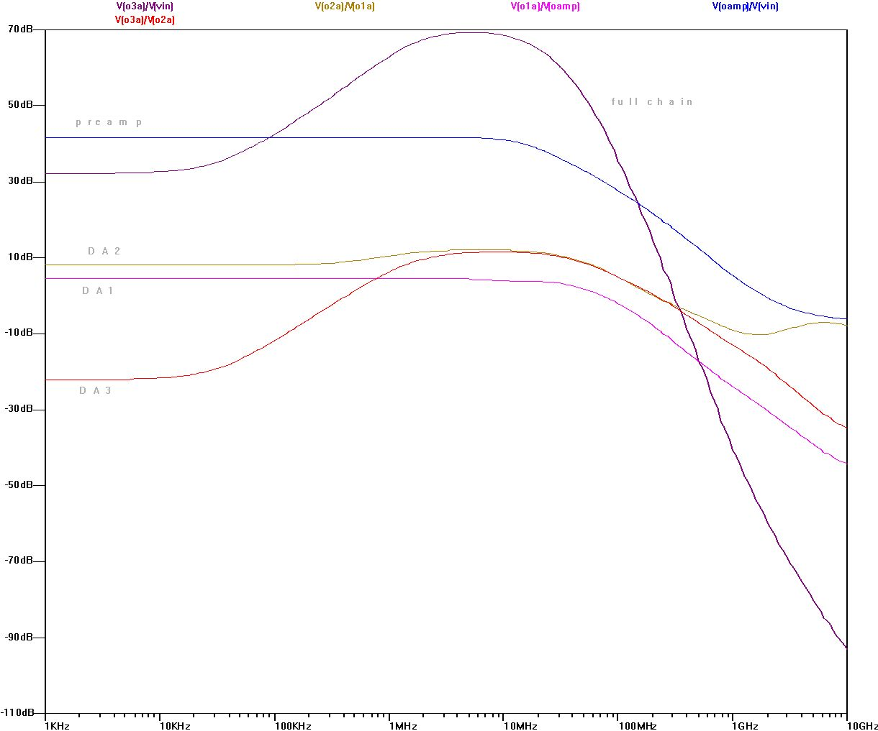
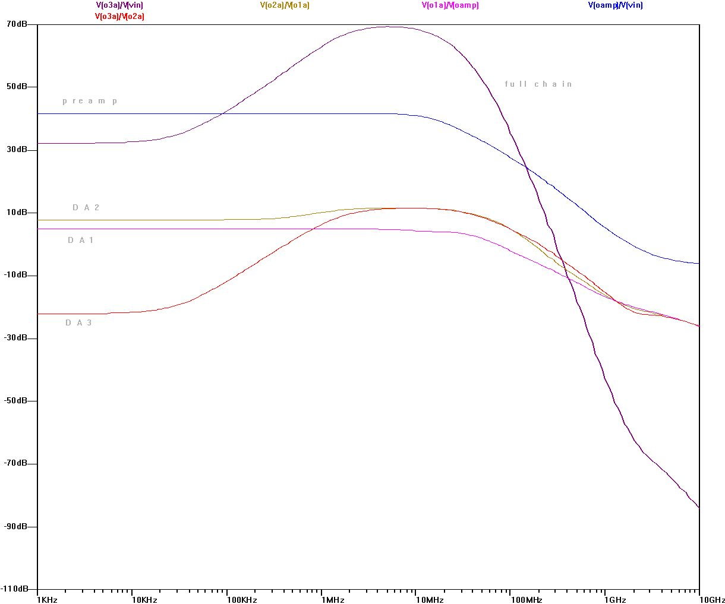

Figure 21B_inverting Figure 21B_noninverting

Note: the second figure is very similar to Figure 21 of ref. [1]

Time domain pulse response
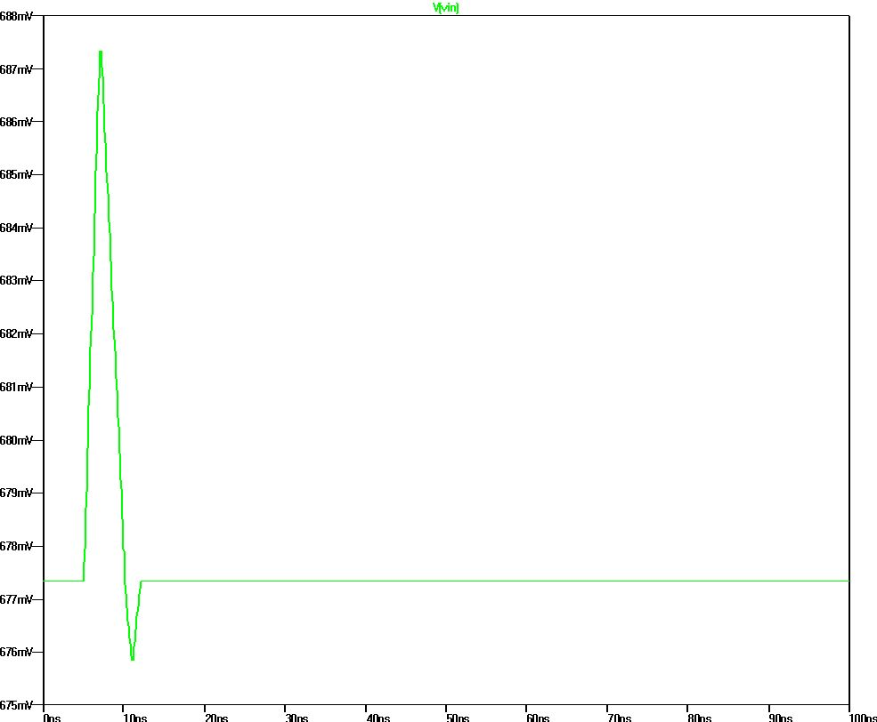

Figure 22B, equivalent of Figure 22a of ref. [1]. Preamplifier input

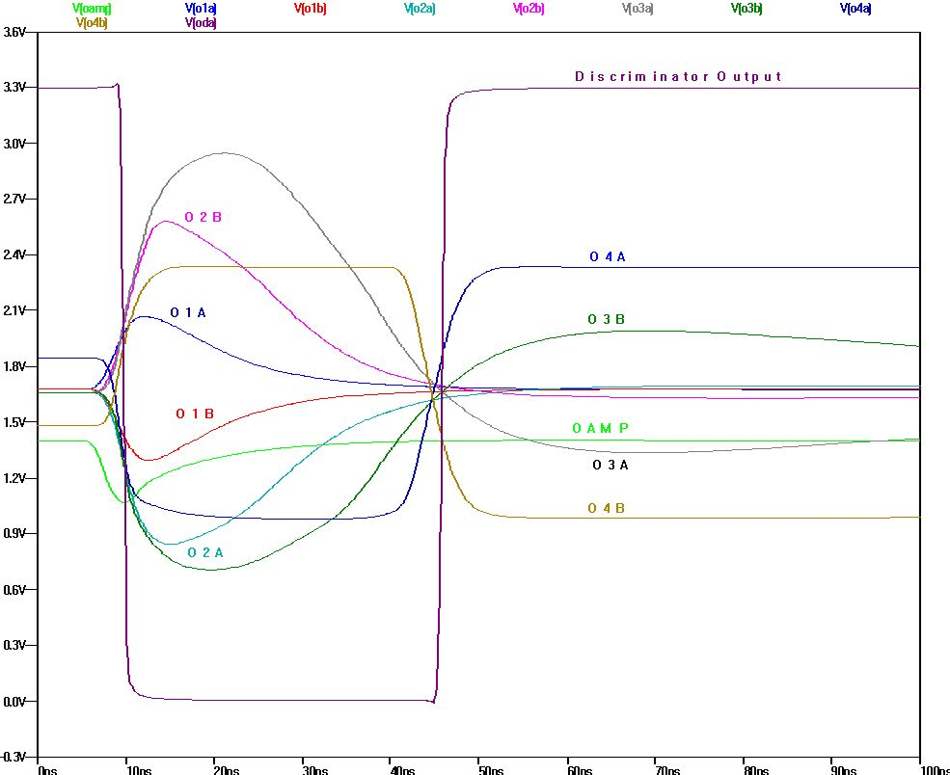

Combined plots equivalent to ref. [1] Figure 22

OAMP – Preamplifier output. Figure 22b
O1A, O1B – Diff. Amp. 1 outputs. Figure 22c
O2A, O2B – Diff. Amp. 2 outputs. Figure 22d
O3A, O3B – Diff. Amp. 3 outputs. Figure 22e
O4A, O4B – Diff. Amp. 4 outputs. Figure 22f
Discriminator Output – no equivalent in ref. [1]

